Chapter-2
1.. What is the purpose of system calls?
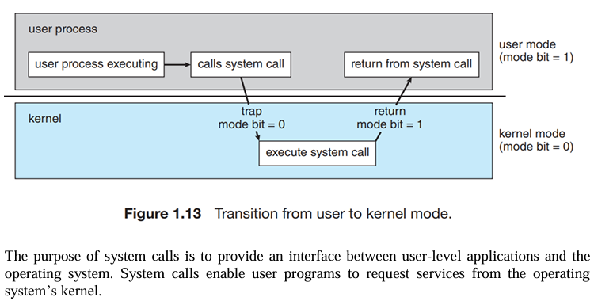
4.. What is the purpose of system programs?
System programs are software tools that help manage, control, and facilitate the use of the computer’s hardware and operating system. They act as an interface between the user and the operating system
Purpose of System Programs:
- Support program development
- Manage files
- Monitor and maintain the system
- Assist in job scheduling and resource management
- Provide user-friendly interfaces
5.. What is the main advantage of the layered approach to system design? What are the disadvantages of the layered approach?
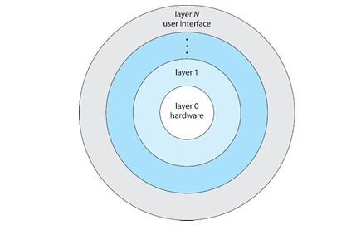
Main Advantage of the Layered Approach:
The main advantage is modularity, which provides the following benefits:
- Simplified Debugging and Maintenance
- Abstraction
Disadvantages of the Layered Approach:
- Performance Overhead
- Layer Dependency
- Complexity in Layering
6.. List five services provided by an operating system, and explain how each creates convenience for users. In which cases would it be impossible for user-level programs to provide these services? Explain your answer.
The five services are:
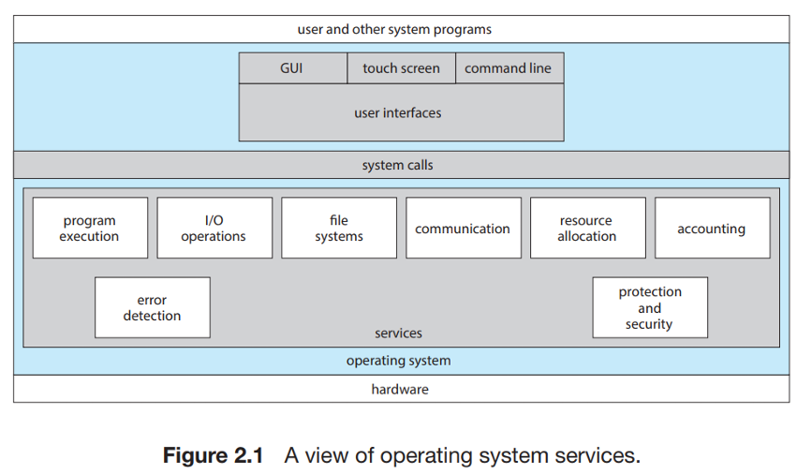
- Program Execution – The OS loads and runs programs.
- File System Management – The OS organizes and manages files on storage devices.
- Communication – The OS allows processes to communicate with each other.
- I/O Management – The OS controls input and output devices.
- Error Detection – The OS detects errors in CPU, memory, and I/O operations.
User-level programs cannot provide these services when
- hardware-level control is required.
- memory protection is needed.
- system-wide resource management is required
- For security and stability reasons
, because these operations are restricted to the OS running in kernel mode.

9.. The services and functions provided by an operating system can be divided into two main categories. Briefly describe the two categories, and discuss how they differ.
Operating system services can be divided into two main categories:
- Protection Services –
The OS protects processes and users from interfering with each other. This keeps the system safe and stable.
- New Functionality Services –
The OS provides features that hardware alone cannot provide, such as virtual memory and file systems.
Difference:
The first category focuses on security and control, while the second adds new useful features beyond hardware capabilities.

10. Describe three general methods for passing parameters to the operating system.
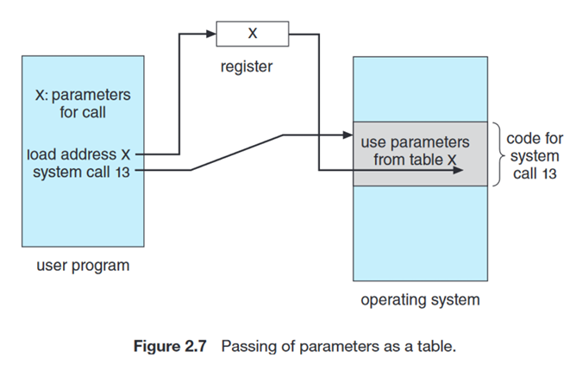
a. Pass parameters in registers
b. Registers pass starting addresses of blocks of parameters
c. Parameters can be placed, or pushed, onto the stack by the program, and popped off the stack by the operating system.

Question 15: What are the two models of inter-process communication? What are the strengths and weaknesses of the two approaches?

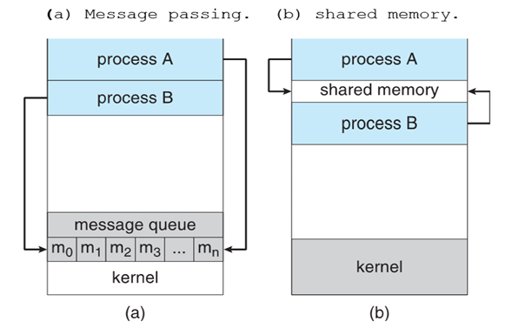
- Message-Passing Model: In this model, processes communicate by sending and receiving messages.
Strengths:
Easier to Implement
No Synchronization Issues
Safer for Small Data

Weaknesses:
Slower for Large Data
Limited by OS

- Shared-Memory Model: In this model, two or more processes share a region of memory.
Strength:
High Speed
Efficient for Large Data

Weaknesses:
Complex Synchronization
Security and Protection
16: Contrast and compare an application programming interface (API) and an application binary interface (ABI).
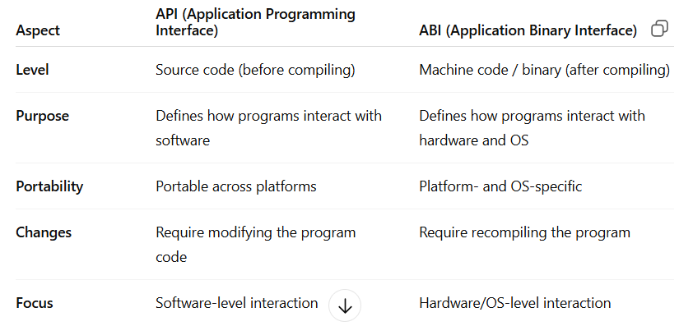
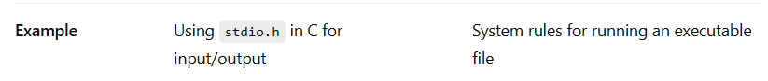

18.. It is sometimes difficult to achieve a layered approach if two components of the operating system are dependent on each other. Identify a scenario in which it is unclear how to layer two system components that require tight coupling of their functionalities.
A scenario where layering is unclear in an Operating System is the tight coupling between the Virtual Memory system and the File System. The memory system depends on the file system to load pages from disk during page faults, while the file system depends on memory management for buffering and caching. This circular dependency makes strict layered design difficult.

19.. What is the main advantage of the microkernel approach to system design? How do user programs and system services interact in a microkernel architecture? What are the disadvantages of using the microkernel approach?

Microkernel Approach
Main Advantages:
- Easily Extensible
- More Secure
- Simpler and Reliable Kernel
User programs and system services interact in a micro-kernel architecture by using inter-process communication mechanisms such as messaging. These messages are conveyed by the operating system.
Disadvantages:
- Performance Overhead
- Complex Communication
- Higher Latency
22. Explain why Java programs running on Android systems do not use the standard Java API and virtual machine.
Answer:
It is because the standard API and virtual machine are designed for desktop and server systems, not mobile devices. Google developed a separate API and virtual machine for mobile devices.

